This document is a template for Waste Management Master Plan at the soum-level that public administrations can use as a base for their Master Plan. The Waste Management Master Plan is the document that should explain how waste is supposed to be managed in your soum, from the moment it is produced (by waste producers) to the moment it is eliminated (through local reusing/recycling, transporting to urban specialized facilities, and/or landfilling). It should be clear and detailed enough for anyone in your soum to perfectly understand your waste management system when reading the Master Plan.
This template includes three types of texts:
- Texts written in red and highlighted in yellow are guidance and advices for the persons in charge of writing the Master Plan: these parts must be removed from the Master Plan when you write and finalize it.
- Texts that are written in black and highlighted in blue are provided as examples. You can keep them as they are or modify them to best suit your soum’s context and needs.
- Texts that are written in black and not highlighted are recommended to be kept as they are, because they are essential measures that Ecosoum considers necessary for setting up a proper waste management system (nevertheless, it is still possible to modify whatever needs to be adapted if you have better ideas that perfectly match your local context, constraints, and needs).
(Delete this explanation box when you are ready to finalize your Waste Management Master Plan.)

Insert soum logo (or other relevant logos) here

WASTE MANAGEMENT MASTER PLAN
OF NAME OF SOUM
Date

Insert other information you consider necessary on the front page

TABLE OF CONTENTS

INTRODUCTION 4
1. AT SOURCE WASTE SORTING AND PROCESSING 4
WASTE SORTING GENERAL RULE AND CATEGORIES 4
WASTE SORTING EQUIPMENT 5
SPECIFIC RECOMMENDATIONS FOR AT-SOURCE SORTING AND PROCESSING 5
WASTE BURNING 5
2. WASTE COLLECTION AND TRANSPORTATION 6
PRIMARY RESPONSIBILITY OF WASTE PRODUCERS 6
PARAMOUNTCY OF WASTE MANAGEMENT PROCESSES AT FACILITY 6
3. WASTE MANAGEMENT FACILITY 6
WASTE MANAGEMENT FACILITY LOCATION 6
GENERAL PLANNING AND INFRASTRUCTURES OF WASTE MANAGEMENT FACILITY 7
MAIN WASTE MANAGEMENT BUILDING AND STORAGE AREA 7
OTHER WASTE AND ULTIMATE WASTE COLLECTION CONTAINERS 8
USERS ROUTE INSIDE THE WASTE MANAGEMENT FACILITY 9
WASTE PROCESSING AND ELIMINATION BY WASTE WORKERS 10
HAZARDOUS WASTE 10
LIVESTOCK CARCASSES 11
4. LANDFILL 11
5. AWARENESS-RAISING ACTIVITIES ON WASTE FOR GENERAL POPULATION 11
6. CONTROLS AND SANCTIONS 12
7. HUMAN, TECHNICAL AND FINANCIAL RESOURCES 12
HUMAN RESOURCES 12
VEHICLES AND MACHINERY 12
FINANCIAL RESOURCES 12

INTRODUCTION

In this introduction, you can provide:
- Brief general information about your soum such as number of population and households (sedentary and herder), number of institutions and other waste producers, etc.;
- Make a waste composition study. This study should be made in summer and winter season taking the following things in consideration: population (by age group), livestock statistics, accommodation, and fuel type, living standard. Based on the results of this composition study the amount of local waste management tax should be calculated, passed and introduced;
- Summary information about waste-related legal framework under which this Master Plan is applicable, including national laws, provincial and local decrees, programs, action plans, etc.;
- Conditions of introduction of this Master Plan (when it was voted, by whom, etc.);
- Information about applicability of this Master Plan (to whom and where does it apply to, for which period, etc.);
- Other general information you consider necessary, such as the goals you want to achieve with this Master Plan.
- AT SOURCE WASTE SORTING AND PROCESSING
WASTE SORTING GENERAL RULE AND CATEGORIES
All waste producers – households (both villagers and herders), public institutions and private businesses – must sort their waste according to the categories below. This obligation to sort waste always applies in all locations of our soum, with no exception, unless a special decree is taken by Local Administration or Khural to authorize otherwise.
The categories of waste according to which it is mandatory for all waste producers to sort their waste at the source are the following:
- Recyclable waste:
- Hard plastics (including PET bottles and other containers);
- Soft plastics (including plastic bags and wrapping);
- Glass (bottles and jars, broken and intact);
- Paper and carton (carton boxes can be used to separate and transport other types of waste);
- Tetra Pak and fabric (in the same bag or separated depending on amounts);
- Metal (cans and other scrap metal);
- Food residue and other organic waste:
- Vegetal waste (vegetable peels, other green waste, etc.);
- Animal waste (meat, bones, fat, food leftover, etc.);
- Ash:
- Wood and livestock dung ash (strictly separated from coal ash);
- Coal ash (strictly separated from wood ash);
- Hazardous and ultimate waste;
- Electronic waste and batteries (together or separated);
- Other hazardous waste (such as oils, paints, etc. – each type separated from one another);
- Ultimate waste (all remaining non-recoverable waste).

You can add more categories if you think it is relevant in your local context.
WASTE SORTING EQUIPMENT
Each of the above 13 categories must be separated from one another in different bags or boxes when brought to the waste management facility or collected by waste collection service.
Waste producers must use in priority the sorting equipment recommended or provided by local authorities or waste management operator (bags, sorting bins, etc.), following their usage recommendations. If no specific equipment is recommended or provided, waste producers are free to use any means at their disposal to sort their waste, in respect of general sorting rules and categories.

You can add specific information about waste sorting equipment applicable in your soum. However, we recommend to remain flexible in this Master Plan so you can easily adapt or modify equipment in the future according to your experience or evolving local context.
SPECIFIC RECOMMENDATIONS FOR AT-SOURCE SORTING AND PROCESSING
Sorted waste (especially categories 1 to 6) must be relatively clean. This means bottles, jars and bags must be fully emptied and properly rinsed (but no need to wash with soap).
In order to reduce the workload of the waste management operator (and thus the costs of the waste management system), waste producers are recommended to manage their organic waste on site, which means as much as possible:
- For vegetal waste (category #7): to either compost them or give them to eat to livestock;
- For animal waste (category #8): to give them to eat to family dogs (but not to stray dogs, to avoid proliferation);
- Organic waste that is not processed on site (composting or animal feeding) must be properly and cleanly separated from other categories of waste to avoid soiling other categories and enable proper processing (composting) within waste management facility.
Carton and paper that do not contain too much ink can be used as carbon matter for composting. Carton and paper can also be used to start stove fires. For composting or starting fires, it is mandatory to remove all plastics (including scotch tape) and it is recommended to remover other impurities (stapples, etc.).
Wood or livestock dung ash can be used as fertilizer or bug repellent in agriculture (or for other usages such as soap manufacturing, etc.). Before using ash for agriculture purposes, people should refer to local agronomist to learn proper usage and avoid misusage. It is forbidden to use coal ash for such purposes as it contains toxic substances.
Hazardous waste that presents a risk of leaking (oils, paints, batteries, etc.) must be put in waterproof containers to avoid pollution.
You can add more specific recommendations for at-source processing that you consider relevant in your soum.
WASTE BURNING
It is strictly forbidden to burn waste. This interdiction applies in all locations and circumstances to all waste producers (households, institutions, businesses) as well as to waste management operators.
Because they are organic and do not create toxic pollution, the only types of waste that can be exceptions to this no-burning rule are:
- Carton and paper can be burnt if all plastics (including scotch tape) are primarily removed (Tetra Paks are not considered paper/carton that can be burnt because they include plastic layers);
- Livestock dung or wood debris can be burnt if they do not contain other substances (additives, paints, etc.);
- Vegetal and animal waste can be burnt, if necessary, although it is recommended to favor composting;
- Medical waste can only be burnt to avoid biohazard, on an exception-basis, if there is absolutely no other option. However, burning medical waste is also hazardous, so it is recommended to implement safer alternatives: hospital must acquire a proper autoclave to decontaminate medical hazardous waste without having to burn it.
You can remove exceptions to the no-burning rules if you want. If you want to add more exceptions, keep in mind that only organic matters (paper/carton, wood, and other vegetal-based products) can be burnt without emitting toxic substances, providing that they do not contain toxic additives (paints, oils and so on).
- WASTE COLLECTION AND TRANSPORTATION
PRIMARY RESPONSIBILITY OF WASTE PRODUCERS
By default, unless proper waste collection service is organized by soum administration or subcontracted local waste management operator, all waste producers – households (both villagers and herders), public institutions and private businesses – are responsible for bringing their own waste (sorted at source) by their own means to the waste management facility.
Systematic waste collection service for all waste producers is seen as a desirable goal, but it is considered a non-essential part of a proper soum-level waste management system. Therefore, it can be decided to postpone introduction of (or temporarily stop) waste collection service if this service compromises more essential aspects of the waste management system, such as at-source sorting or processing in the facility. Waste collection service can be used as leverage or incentive to force waste producers to properly sort their waste.
The fact that waste producers sort their waste and/or pay a local waste management tax does not mean they are automatically entitled to waste collection service. Likewise, the fact that waste collection service may not be organized does not mean waste producers are allowed not to sort their waste or stop paying applicable taxes.
PARAMOUNTCY OF WASTE MANAGEMENT PROCESSES AT FACILITY
Whether they are transported by waste producers themselves or by collection service, all categories of waste – including ash and ultimate waste – must be transported exclusively to the waste management facility where they are to be processed according to the established processes. No waste (even considered ‘ultimate’) can be dumped by waste producers directly at the landfill (and even more so in other locations), unless they are granted specific authorization by relevant authorities and accompanied by waste management staff.
If waste collection service is organized, for some or all groups of waste producers, such service must be carried out in a way that does not compromise neither the established processes nor the local waste management system. For instance, the degree and effectiveness of at-source waste-sorting must always be sufficient and consistent to allow processes in place at waste management facility to remain unchanged (especially when the aforesaid processes involved the participation of waste producers themselves before the launch of waste collection service).
Waste producers who are offered waste collection service must respect the collection rules established by local authorities and/or waste management operator. If these rules are not respected (for instance if waste is not properly sorted), waste collectors can refuse collecting waste.
You can add or remove clauses and rules about waste collection and transportation, but keep in mind that such service must never compromise, in any way, proper at-source sorting and proper processing in waste management facility.
- WASTE MANAGEMENT FACILITY
WASTE MANAGEMENT FACILITY LOCATION
Add brief explanation about location of waste management facility, as well as a location map. If there are other waste-related locations in your soum (temporary collection points, etc.), indicate them also on the map and provide brief explanation. If you do not include a specific map indicating your landfill (in the ‘4. LANDFILL’ section below), you can locate the landfill on this map.
GENERAL PLANNING AND INFRASTRUCTURES OF WASTE MANAGEMENT FACILITY
Add description of existing or planned waste management facility (size, description of infrastructures, etc.). You should include a general layout drawing of the whole premise, including all buildings and outdoor spaces. For example, your description should look like the following:
The waste management facility covers a square surface of 2,500m² (50x50m). It includes:
- a main building, where recyclables are brought by waste producers (‘users’ of the facility) and processed by waste workers (waste management facility staff) in different ways;
- an annex storage building where sorted and processed waste is temporarily and properly stored until final elimination (either delivery to urban recyclers or local reusing);
- a garage, where waste management vehicles can be protected from extreme weather conditions in winter (this garage can also be used as workshop by waste management staff if necessary);
- an ultimate waste collection container, where ultimate waste is temporarily gathered and stored until elimination to the landfill;
- a separate wood ash container, next to ultimate waste container, to collect valuable wood ash that can be used in agriculture;
- a composting area for food waste (which should be separated between vegetable and animal waste);
- extra sheds, containers and other small infrastructures and equipment for tools and secondary waste management processes.
General layout drawing of the facility is presented below.

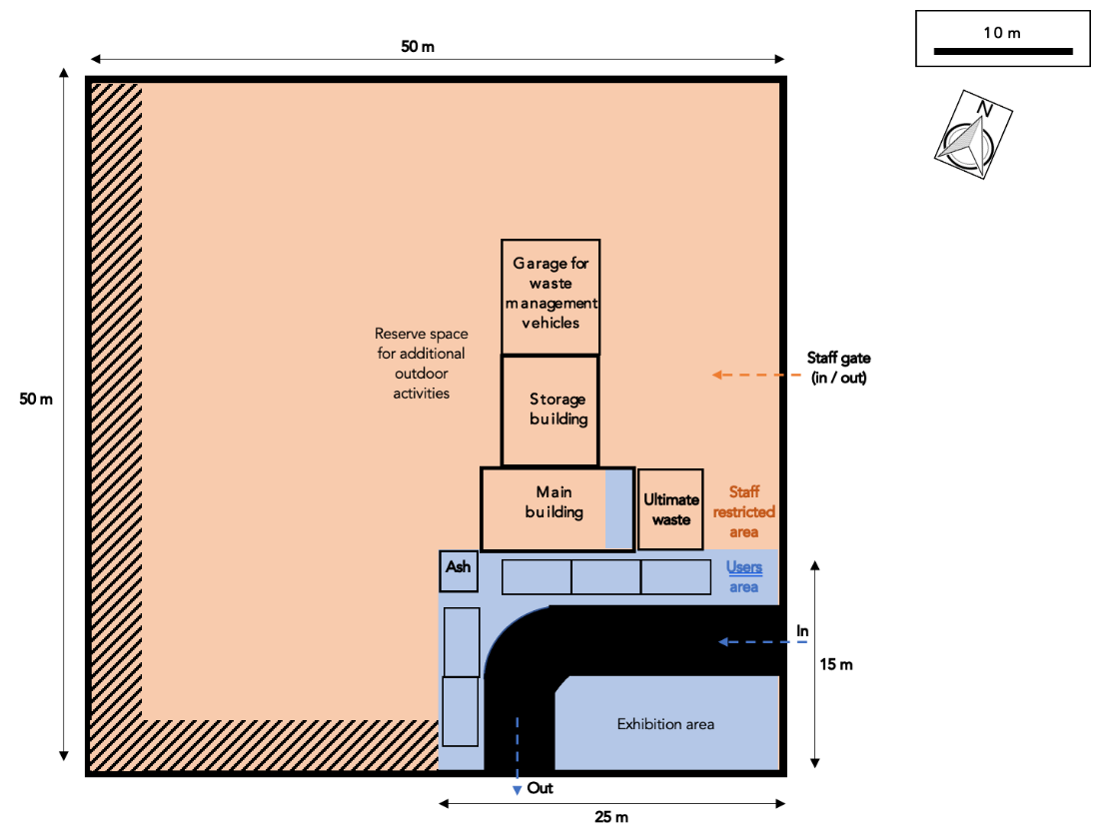
MAIN WASTE MANAGEMENT BUILDING AND STORAGE AREA
Add description of existing or planned waste management building. There is no need to respect an exact size or layout: you can adapt with whatever relevant building is available in your soum. The essential aspects are to have:
- a users’ area where people can safely drop their sorted waste while seeing the rest of the building (to understand how waste is processed by waste workers);
- enough space for waste workers to sort and process waste (if possible, at least 50m² including users’ area);
- enough indoor space to properly store processed recyclables (glass bottles, pressed plastic, etc.) before transportation to professional recyclers (if possible, at least 25m², which can be a separate building or extra space in the main building in addition to the 50m² for sorting/processing).
For example, your description should look like the following (it should also include a layout drawing):
The main building is divided into one limited area for users to come and drop their sorted waste, and another staff restricted area (recycling room) where waste is further sorted and processed. Storage room is accessible from the recycling room and offers enough space to temporarily store valuable recyclables by category until they are taken out for transportation to urban recycling industries or for local recycling.

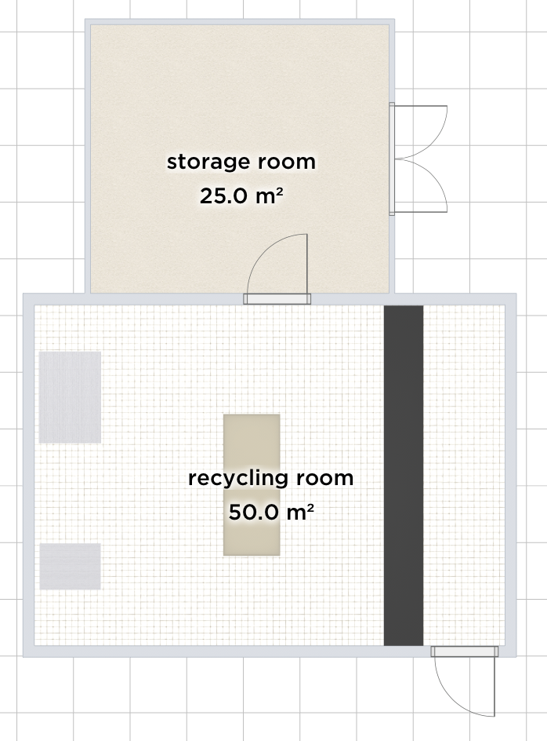
Users’ area
Press
Shredder
Sorting workbench
OTHER WASTE AND ULTIMATE WASTE COLLECTION CONTAINERS
As waste producers must be forbidden to bring their ultimate waste directly to the landfill, an ultimate waste collection point where users can dispose their ultimate waste bags must be set up in the premises of the waste management facility, next to the main building. We recommend to design a container that is convenient and practical both for people to drop their waste and for waste management staff to subsequently take it out and put it in the truck for transportation and disposal at dumpsite.
If you have enough trucks, it can be relevant to arrange that users throw their ultimate waste directly in the truck so that waste management staff does not have to do it (saving time and effort) and can directly empty the truck in the landfill when it is full. If you do not want to immobilize your truck in the facility (for instance if you need it for collecting waste), a relevant alternative can be to put the ultimate waste container on wheels or use a trailer, and then use the truck to pull the trailer/container to empty it at the landfill.
Whatever option you choose, make sure that the design of the ultimate waste container prevents wind scattering: it should be closed (or at least covered with a tarp) so that waste cannot fly away when it is windy.
Finally, you should clarify the containers where users will put the types of waste that are not disposed inside the building (organic waste, ash, ultimate waste).
For example, this section could look like the following:
When users bring their sorted waste to the facility, they must dispose their ultimate waste into the dedicated ultimate waste collection point. By default, this collection point is the truck located left of the exit gate. If the truck is temporarily absent (being used somewhere else), users must dispose their ultimate waste in the alternative container indicated by waste management staff. Ultimate waste must be disposed into the collection point in a closed plastic bag or a carton box, to reduce risks of wind scattering.
Coal ash must be disposed with ultimate waste, also in closed bags or boxes.
Wood ash should be disposed in a separate container to enable its valorization.
Organic waste should be disposed in a dedicated composting area.
Hazardous waste should be safety stored in a dedicated area, separated from other types of waste.
Waste management staff should control that ultimate waste bags or boxes disposed by users do not include recyclable waste that should have been sorted (according to above categories). In case waste was not sorted properly, waste management staff must require users to immediately open the bag/box and recover the recyclable waste. In such a case, protective gloves must be provided to users.
In case users repeatedly fail to sort their waste properly or refuse to comply when asked to recover unsorted waste from their bags/boxes, waste management staff should report the incident to competent authorities.
USERS ROUTE INSIDE THE WASTE MANAGEMENT FACILITY
This section should clarify precisely what users who bring their waste should do and where exactly they should go within the premises of the waste management facility. Your explanation should look like the following:
Users (waste producers) bringing their waste to the waste management facility should enter through the South main gate and park in front of the main building. Then, they must start by bringing their bags and/or boxes of sorted recyclable waste into the building. If they have a lot, waste management staff can help them bring the bags/boxes in.
In the limited public area to which users have access, users must empty their bags of recyclables by themselves in the proper sorting holes spread over the sorting workbench, under which containers on wheels are installed to receive disposed recyclables sorted by category. Users can be assisted in this task by waste management facility staff, who should make sure waste is properly sorted and offer support and explanation if necessary.
In case some rules were not fully respected (for instance, if recyclables are not clean enough), waste management staff must kindly explain the mistake, so users can improve next time. In case the same mistake is repeated several times by the same user, waste management staff can refuse to accept the incriminated (dirty) waste and require users to take it back home to fix the problem (for example, properly empty and rinse containers). In case users refuse to comply, waste management staff should report the incident to competent authorities.
After disposing recyclables in the main building, users should move their vehicle next to the appropriate containers and dispose their remaining waste (organic waste, ashes, ultimate waste) as described above. A waste worker will join users during this process so he/she can help and make sure each type of waste is disposed in the appropriate container, in respect for established rules detailed above.
When users have disposed all their waste, they can exit the waste management facility without ever going to the landfill. If, on an exceptional basis, waste workers and waste producers agree there is a good reason for waste producers to dispose their waste directly at the landfill (for instance, if they have a truck full of demolition waste), waste workers must accompany them to oversee the process and make sure waste is disposed properly and safely.
WASTE PROCESSING AND ELIMINATION BY WASTE WORKERS
This section should clarify precisely how the waste management team is supposed to process and eliminate each category of waste that are brought to the facility. Your explanation should look like the following:
Once recyclables are dropped off by users in the sorting workbench (or brought in by waste collection service), they should be taken from containers under the workbench and further sorted into relevant subcategories. Then, each type of recyclable should be processed by waste management staff according to pre-established processes. These processes may evolve over time depending on needs and opportunities, but main guidelines are:
- All recyclable plastics should be sorted by subcategory (transparent PET bottles, dark PET bottles, HDPE containers, PP containers, HDPE and LDPE soft plastic, PP soft plastic) and pressed separately. Pressed plastics should be stored in storage area until they are taken to urban recyclers.
- Glass bottles and jars that are taken back by industry should be carefully stored until they are transported to their respective industries for reusing. Other types of glass waste that cannot be sold back for reusing should be crushed and stored for local reuse/recycling (for example, as aggregate for concrete instead of gravel or sand).
- Reusable cartons should be locally given away or directly used for packaging/storage. Non-reusable paper and carton can be used for local composting or burnt in the facility if they are in small amount; otherwise, if there is a lot, they should be pressed and properly stored until transportation to urban recyclers.
- Aluminum cans should be pressed and stored similarly to plastics before to be sold to urban recyclers.
- Other types of waste that can be sold somewhere can be processed similarly or any other relevant way;
- Other types of waste that are theoretically recyclable but for which no proper waste management channels are currently available in Mongolia (Tetra Paks, steel cans, e-waste, etc.) should be:
  - whenever possible/relevant: sorted, audited to produce data, and stored until processing channel is available;
  - in other cases: disposed in landfill with ultimate waste.
Pressed and stored recyclable waste should be transported and sold to the nearest (or more profitable) reusing/recycling channels, such as companies of origin (for glass bottles and containers) or professional recycling companies (for plastics, aluminum, and paper).
Organic waste should be composted. Mature compost should be valorized in agricultural activities.
As much as possible, wood ash should also be valorized in agricultural activities. If no valorization channel is temporarily available or possible, wood ash can be disposed with ultimate waste. (Unless it is forbidden by national laws, it can be more relevant to dispose wood ash and livestock dung ash anywhere in the steppe to fertilize the soils, because wood and dung ash is non-polluting organic matter. Disposing these ashes in random places out in the countryside rather than in the landfill would also mean that the landfill does not get full too fast and that the soum does not require to create a new landfill too often, which would save money.)
Once the ultimate waste container (truck or trailer) is full, ultimate waste (including coal ash) should be transported and disposed in the landfill.
HAZARDOUS WASTE
If relevant and applicable solutions in line with Mongolian law can be implemented for transporting and properly processing hazardous waste in specialized facilities in Ulaanbaatar or other cities, such solutions shall be favored.
In case hazardous waste must be handled locally in the soum because there is no other realistic solution, it should be stored in the soil in the safest possible way. A specific area for hazardous waste should be delimited in the landfill so that it is never mixed with other types of non-hazardous waste.
Different types of hazardous waste should not be mixed in order to avoid that they react together. Hazardous waste should be stored in solid waterproof barrels, which should be constituted of a relevant material (metal or plastic) according to the nature of the stored substance/waste.
Buried hazardous waste should be monitored and content of barrels should be registered. Burial location should be recorded and physically marked on site.
LIVESTOCK CARCASSES
This section should clarify precisely how dead animal carcasses are supposed to be managed in your soum. Broadly speaking, we recommend not to dispose carcasses in the main landfill, to avoid all forms of contamination. If possible and authorized by national laws, we suggest to dedicate a specific area (outside the landfill) to carcasses disposal and favor natural processing ways involving scavenger birds like vultures (which can eat and eliminate the carcasses). However, if carcasses are suspected to carry contagious diseases, they must be processed according to official standards and/or buried very carefully in a specific and protected area (not in the landfill). You must discuss with your herder community and consult specialists, including your local veterinarians, to decide how to manage animal carcasses in your soum.
- LANDFILL
This section should clarify precisely how the landfill is supposed to be organized and operated (you should include a location map and a layout drawing of the landfill). If your current dumpsite is not sufficiently safe and/or does not match the requirements below, you should clarify how you plan to make it secure). Your explanation should look like the following:
Entrance of landfill must be strictly limited to authorized personnel of the waste management facility. Waste producers may be authorized to enter the landfill on exceptional basis (if there is a good reason why they need to dump waste directly from their own vehicle), but only under supervision of the aforesaid authorized staff.
All waste disposed in the landfill should have previously been assessed by waste management staff to make sure it cannot be recovered or recycled any further.
Disposed ultimate waste should be compacted with a bulldozer to reduce total volume of waste and stabilize the pilled waste (to enable driving over previously disposed waste with the truck).
Disposed ultimate waste should strictly be covered with soil or other appropriate material (such as heavy coal ash from local heating plant). This covering should be implemented regularly to prevent waste scattering. Covering operations should be carried out at the very least once a month, but, if possible, more frequently (after each disposal would be best), especially when light and easily-scattered types of waste are disposed of (and especially during spring time, when winds are the strongest).
- AWARENESS-RAISING ACTIVITIES ON WASTE FOR GENERAL POPULATION
This section should clarify how you are planning to raise awareness about waste issue in general among your entire population. You should have a clear action plan to reach all age groups such as kindergarten pupils, general education school students, youth, herders, elderly people, public institution staff etc. Activities should include regular formal and informal trainings through different types of means such as videos, reports, presentations, contests, campaigns, and public events. In order to improve people’s knowledge on waste, all kinds of activities should be carried out non-stop. Changing mindsets and introducing new habits take a lot of time, money, and effort, thus requiring careful plans for long period of time.

- CONTROLS AND SANCTIONS
This section should clarify precisely how you will control that waste producers are respecting the rules and what you plan to do if people do not respect this Master Plan’s regulations. Who will oversee controlling that people sort at the source, and how frequently? If at-source waste sorting is officially mandatory (as it must be), what sanction will you impose on waste producers who do not sort their waste? If people misuse waste sorting equipment that you may distribute, what will you do? If people trespass the landfill perimeter although they are not authorized, how will you sanction them? If waste is littered into the environment, how will you punish the polluters?
It is essential to organize some forms of control and plan all possible violations to associate each of them with a clear answer from local authorities (fine and/or other form of sanction).
- HUMAN, TECHNICAL AND FINANCIAL RESOURCES
HUMAN RESOURCES
This section should clarify who will oversee what, and how many full-time staff should oversee operating waste management in the soum. As much as possible, Local administration should remain in charge of waste management, in order to make sure that the waste management system remains exhaustive and general interest-oriented (rather than being turned into a private profit-making operation disregarding non-valuable types of waste). As such, the best option would be that local administration directly hires relevant staff and keeps daily waste management operation under its direct control (unless there is already a TUK entity in place in your soum).
If this first option cannot be implemented and waste management must be subcontracted to another entity, it should be preferably contracted to a public or non-profit operator, or at least to a local community-based organization (such as soum-based cooperative). In case of such subcontracting, a clear framework and terms of references should be contractually clarified – rather than leave the subcontractor operate however he/she intends. More precisely, the subcontractor should be fully remunerated by local administration for a specific service (e.g., properly managing all types of waste according to local waste management Master Plan in exchange for being paid XXX million MNT per year) rather than asking the subcontractor to remunerate themself by trading valuable recyclables (which would turn soum-level waste management into a market-oriented business, with all the risks associated with such an approach). Therefore, the money raised from trading recyclables should be used exclusively to improve the waste management system and/or be added to soum general budget (which, in turn, can be used to pay part of subcontractor’s fee).
In any case, for an average soum, we usually recommend to have at least 2 full-time staff working in the waste management facility and at least 1 or 2 more staff (3 or 4 in total) if you plan to implement extensive waste collection service.
VEHICLES AND MACHINERY
This section should summarize vehicles and machinery you plan to use to implement your waste management system. We recommend to have at least:
- one or two trucks;
- one small bulldozer or similar machinery for the landfill (to move and compact disposed waste);
- one press-machine to press plastic and other recyclables in the facility;
- one glass crusher to turn broken glass into sand/gravel.
FINANCIAL RESOURCES
This section should clarify how your waste management system (as described in this Master Plan) will be sustainably financed. You should calculate your waste management budget using Ecosoum’s waste management budget calculator (considering both investments and operational running costs) and put the budget table in annex to this Master Plan.
We recommend that the operational costs should be primarily covered by a dedicated waste management local tax. This tax should be introduced and collected by local administration to raise enough money to sustainably pay at least two full-time waste management staff as well as other operation costs (maintenance, electricity, gas, etc.). Additional funding should be generated by selling recyclables to urban recyclers; this money should be used to cover part of the running costs (including salary of additional staff) in addition to the local tax. Investments (new truck, new machine, etc.) should be covered by soum or aimag general budget whenever necessary. The money collected from sanction fines should be injected into the waste management budget.

